Arjuna CLF 2.0

Programmer's Guide
CLF-PG-11/8/26

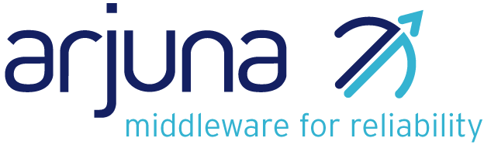

Legal Notices
The information contained in this documentation is subject to change without notice.
Arjuna Technologies Limited makes no warranty of any kind with regard to this material, including, but not limited to, the implied warranties of merchantability and fitness for a particular purpose. Arjuna Technologies Limited shall not be liable for errors contained herein or for incidental or consequential damages in connection with the furnishing, performance, or use of this material.
Java™ and J2EE is a U.S. trademark of Sun Microsystems, Inc. Microsoft® and Windows NT® are registered trademarks of Microsoft Corporation. Oracle® is a registered U.S. trademark and Oracle9™, Oracle9 Server™ Oracle9 Enterprise Edition™ are trademarks of Oracle Corporation. Unix is used here as a generic term covering all versions of the UNIX® operating system. UNIX is a registered trademark in the United States and other countries, licensed exclusively through X/Open Company Limited.
Arjuna is a trademark of Hewlett-Packard Company.
Software Version
Arjuna CLF 2.0
Restricted Rights Legend
Use, duplication, or disclosure is subject to restrictions as set forth in contract subdivision (c)(1)(ii) of the Rights in Technical Data and Computer Software clause 52.227-FAR14.
Arjuna Technologies Limited
Nanotechnology Centre
Herschel Building
Newcastle Upon Tyne
NE1 7RU
United Kingdom
© Copyright 2026 Arjuna Technologies Limited

Content
About This Guide 4
What This Guide Contains 4
Audience 4
Organization 4
Documentation Conventions 4
Overview 6
CLF 2.0 Architecture 6
Package Overview: com.arjuna.common.util.logging 7
LogFactory 7
Setup of Log subsystem 7
Getting Started 9
Log Interface 10
Dependencies 10
Default File Logging 11
Overview 11
Setup 11
Fine-Grained Logging 12
Overview 12
Usage 12
Index 15

About This Guide

What This Guide Contains
The Programmer's Guide contains information on how to use Arjuna CLF 2.0.

Audience
This guide is most relevant to engineers who are responsible for using Arjuna CLF 2.0 installations.

Organization
This guide contains the following chapters:
- Chapter 1, Overview
- Chapter 2, Migration to CLF 2.0
- Chapter 3, Helper Classes
- Chapter 4, The Log Interface

Documentation Conventions
The following conventions are used in this guide:
Convention | Description
Italic | In paragraph text, italic identifies the titles of documents that are being referenced. When used in conjunction with the Code text described below, italics identify a variable that should be replaced by the user with an actual value.
Bold | Emphasizes items of particular importance.
Code | Text that represents programming code.
Function | Function | A path to a function or dialog box within an interface. For example, “Select File | Open.” indicates that you should select the Open function from the File menu.
( ) and | | Parentheses enclose optional items in command syntax. The vertical bar separates syntax items in a list of choices. For example, any of the following three items can be entered in this syntax:  persistPolicy (Never | OnTimer | OnUpdate | NoMoreOftenThan)
Note: and  Caution: | A note highlights important supplemental information.  A caution highlights procedures or information that is necessary to avoid damage to equipment, damage to software, loss of data, or invalid test results.
Table 1 Formatting Conventions

Overview

CLF 2.0 Architecture
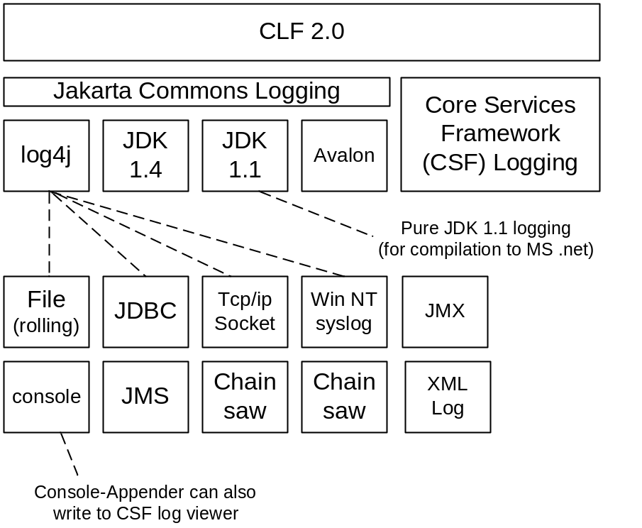
Figure 0-1 CLF 2.0 Architecture

Package Overview: com.arjuna.common.util.logging

Interface Summary
Logi18n | A simple logging interface abstracting the various logging APIs supported by CLF and providing an internationalization layer based on resource bundles.
LogNoi18n | A simple logging interface abstracting the various logging APIs supported by CLF without internationalization support

Class Summary
CommonDebugLevel | The CommonDebugLevel class provides default finer debugging value to determine if finer debugging is allowed or not.
CommonFacilityCode | The CommonFacilityCode class provides default finer facilitycode value to determine if finer debugging is allowed or not.
CommonVisibilityLevel | The CommonVisibilityLevel class provides default finer visibility value to determine if finer debugging is allowed or not.
LogFactory | Factory for Log objects.

LogFactory
Factory for Log objects. LogFactory returns different subclasses of logger according to which logging subsystem is chosen. The log system is selected through the property com.arjuna.common.utils.logger. Supported log systems are:
- jakarta Jakarta Commons Logging (JCL). JCL can delegate to various other logging subsystems, such as:
  - log4j
  - JDK 1.4 logging
  - JDK 1.1 based logging (for compilation to Microsoft .net)
  - Avalon
- dotnet .net logging. (must be JDK 1.1 compliant for compilation by the Microsoft compiler)
Note that rather than implementing CSF and .net logging as additional loggers for JCL they have been anchored at this level to maximise code reuse and guarantee that all .net dependent code is 1.1 compliant. Log subsystems are not configured through CLF but instead rely on their own configuration files for the setup of eg. debug level, appenders, etc...

Setup of Log subsystem
The underlying log system can be selected in two ways:
- Through the commonPropertyManager:
com.arjuna.common.internal.util.logging.commonPropertyManager.
propertyManager.setProperty(“com.arjuna.common.util.logger”, “csf”);
- As a System property (see following table)
Property Name | Description
com.arjuna.common.util.logger  property name is defined as the public constant: LogFactory.LOGGER_PROPERTY | This property selects the log subsystem to use. Note that this can only be set as a System property, e.g. as a parameter to start up the client application:  java –Dcom.arjuna.common.util.logger=log4j ..
Table 2 System property to select the underlying log system to use.
The properties of the underlying log system are configured in a manner specific to that log system, e.g., a log4j.properties file in the case that log4j logging is used.

Property Value | Description
log4j | Log4j logging (log4j classes must be available in the classpath); configuration through the log4j.properties file, which is picked up from the CLASSPATH or given through a System property: log4j.configuration
jdk14 | JDK 1.4 logging API (only supported on JVMs of version 1.4 or higher). Configuration is done through a file logging.properties in the jre/lib directory.
simple | Selects the simple JDK 1.1 compatible console-based logger provided by Jakarta Commons Logging
jakarta | Uses the default log system selection algorithm of the Jakarta Commons Logging framework
dotnet | Selects a .net logging implementation  Since a dotnet logger is not currently implemented, this is currently identical to simple. Simple is a purely JDK1.1 console-based log implementation.
noop | Disables all logging
Table 3 Possible values for selecting the client-side logging system.
Example: To set of log4j (default log system), provide the following System properties:
-Dcom.arjuna.common.util.logger=log4j
-Dlog4j.configuration=file://c:/Projects/common/log4j.properties

Getting Started
Simple use example:
import com.arjuna.common.util.logging.*;

public class Test
{
static Log mylog = LogFactory.getLog(Test.class);

public static void main(String[] args)
{
String param0 = "foo";
String param1 = "bar";

// different log priorities
mylog.debug("key1", new Object[]{param0, param1});
mylog.info("key2", new Object[]{param0, param1});
mylog.warn("key3", new Object[]{param0, param1});
mylog.error("key4", new Object[]{param0, param1});
mylog.fatal("key5", new Object[]{param0, param1});

// optional throwable
Throwable throwable = new Throwable();
mylog.debug("key1", new Object[]{param0, param1}, throwable);
mylog.info("key2", new Object[]{param0, param1}, throwable);
mylog.warn("key3", new Object[]{param0, param1}, throwable);
mylog.error("key4", new Object[]{param0, param1}, throwable);
mylog.fatal("key5", new Object[]{param0, param1}, throwable);

// debug guard to avoid an expensive operation if the logger does not
// log at the given level:
if (mylog.isDebugEnabled())
{
String x = expensiveOperation();
mylog.debug("key6", new Object[]{x});
}

// ******************************************************
// fine-grained debug extensions
mylog.debug(CommonDebugLevel.OPERATORS,
CommonVisibilityLevel.VIS_PUBLIC,
CommonFacilityCode.FAC_ALL,
"This debug message is enabled since it matches default” +
Finer Values");

mylog.setVisibilityLevel(CommonVisibilityLevel.VIS_PACKAGE);
mylog.setDebugLevel(CommonDebugLevel.CONSTRUCT_AND_DESTRUCT);
mylog.setFacilityCode(CommonFacilityCode.FAC_ALL);

mylog.mergeDebugLevel(CommonDebugLevel.ERROR_MESSAGES);

if (mylog.debugAllowed(CommonDebugLevel.OPERATORS,
CommonVisibilityLevel.VIS_PUBLIC,
CommonFacilityCode.FAC_ALL))
{
mylog.debug(CommonDebugLevel.OPERATORS,
CommonVisibilityLevel.VIS_PUBLIC,
CommonFacilityCode.FAC_ALL,
"key7", new Object[]{"foo", "bar"}, throwable);
}
}
}

Log Interface
A simple logging interface abstracting the various logging APIs supported by CLF.
The logging levels used by Log are (in order):
- debug (the least serious)
- info
- warn
- error
- fatal (the most serious)
The mapping of these log levels to the concepts used by the underlying logging system is implementation dependent. The implemention should ensure, though, that this ordering behaves as expected.
Performance is often a logging concern. By examining the appropriate property, a component can avoid expensive operations (producing information to be logged).
For example,
if (log.isDebugEnabled()) {
... do something expensive ...
log.debug(...);
}
Configuration of the underlying logging system will generally be done external to the Logging APIs, through whatever mechanism is supported by that system.

Dependencies
Name | Description
commons-logging.jar | Jakarta Commons Logging JAR (v. 1.0.3)
log4j-1.2.8.jar | Log4j Jar file (required when using log4j)
mw-common.jar | (for CSF logging)
csf.jar | (for CSF logging)
Table 4 Jar file dependencies
At runtime, it is important, that log4j-1.2.8.jar appears after common.jar in the CLASSPATH. The reason is the CLF overrides a class in log4j that is required to print out correct line number information in the log.

Default File Logging

Overview
Independent of the log system chosen, it is possible to log all messages over a given severity threshold into a file. This is useful to guarantee that e.g., error and fatal level messages are not lost despite a user has not set up a log framework, such as log4j

Setup
Usage of this feature is simple and can be controlled through a set of properties. These can be provided through the Property Manager or as System properties.
Property Name | Values | Description
com.arjuna.common.logging.default | true/false | Enable/disable default file-based logging
com.arjuna.common.util.logging.  default.level | Info/error/fatal | Severity level for this log
com.arjuna.common.util.logging.  default.showLogName | true/false | Record the fully qualified log name
com.arjuna.common.util.logging.  default.showShortLogName | true/false | Record an abbreviated log name
com.arjuna.common.util.logging.  default.showDate | true/false | Record the date
com.arjuna.common.util.logging.  default.logFile | error.log (default) | File to use for default logging. This can be an absolute filename or relative to the working directory
com.arjuna.common.util.logging.  default.logFileAppend | true/false | Append to the log file above in case that this file already exists
Table 5 Properties to control default file-based logging (default values are highlighted)

Fine-Grained Logging

Overview
Finer-grained logging in CLF is available through a set of debug methods:
public void debug(long dl, long vl, long fl, Object message);
public void debug(long dl, long vl, long fl, Throwable throwable);
public void debug(long dl, long vl, long fl, String key, Object[] params);
public void debug(long dl, long vl, long fl, String key, Object[] params,
Throwable throwable);
All of these methods take the three following parameters in addition to the log messages and possible exception:
dl - The debug finer level associated with the log message. That is, the logger object allows to log only if the DEBUG level is allowed and dl is either equals or greater the debug level assigned to the logger Object See Table 6 for possible values.
vl - The visibility level associated with the log message. That is, the logger object allows to log only if the DEBUG level is allowed and vl is either equals or greater the visibility level assigned to the logger Object See Table 8 for possible values.
fl - The facility code level associated with the log message. That is, the logger object allows to log only if the DEBUG level is allowed and fl is either equals or greater the facility code level assigned to the logger Object See Table 7 for possible values.
The debug message is sent to the output only if the specified debug level, visibility level, and facility code match those allowed by the logger.
The first two methods above do not use i18n. i.e., the messages are directly used for log output.

Usage
Possible values for debug finer level, visibility level and facility code level are declared in the classes DebugLevel, VisibilityLevel and FacilityCode respectively. This is useful for programmatically using fine-grained debugging.
Debug Finer Level | Value | Description
NO_DEBUGGING | 0x0000 | no debugging
CONSTRUCTORS | 0x0001 | only output from constructors
DESTRUCTORS | 0x0002 | only output from finalizers
CONSTRUCT_AND_DESTRUCT | CONSTRUCTORS | DESTRUCTORS
FUNCTIONS | 0x0010 | only output from methods
OPERATORS | 0x0020 | only output from methods such as equals, notEquals
FUNCS_AND_OPS | FUNCTIONS | OPERATORS
ALL_NON_TRIVIAL | CONSTRUCT_AND_DESTRUCT | FUNCTIONS | OPERATORS
TRIVIAL_FUNCS | 0x0100 | only output from trivial methods
TRIVIAL_OPERATORS | 0x0200 | only output from trivial operators
ALL_TRIVIAL | TRIVIAL_FUNCS | TRIVIAL_OPERATORS
ERROR_MESSAGES | 0x0400 | only output from debugging error/warning messages
FULL_DEBUGGING | 0xffff | output all debugging messages
Table 6 Possible settings for finer debug level (class DebugLevel)
Visibility Level |  | Value |  | Description
VIS_NONE |  | 0x0000 |  | no visibility
VIS_PRIVATE |  | 0x0001 |  | only from private methods
VIS_PROTECTED |  | 0x0002 |  | only from protected methods
VIS_PUBLIC |  | 0x0004 |  | only from public methods
VIS_PACKAGE | 0x0008 |  | only from package methods
VIS_ALL | 0xffff |  | output all visbility levels
Table 7 Possible settings for visibility level (class VisibilityLevel)
Facility Code Level | Value | Description
FAC_NONE | 0x00000000 | no facility
FAC_ALL | 0xffffffff | output all facility codes
Table 8 Possible settings for facility code level (class FacilityCode)
At runtime, the fine-grained debug settings are controlled through a set of properties, listed in the table below:
Property Name | Default Value
com.arjuna.common.util.logging.DebugLevel | NO_DEBUGGING
com.arjuna.common.util.logging.VisibilityLevel | VIS_ALL
com.arjuna.common.util.logging.FacilityCode | FAC_ALL

Index
Error! No index entries found.

